Advocacy Day 2022 Social Media Toolkit

Hashtags:
#crisis4iavictims
#investinsurvivors
#supportiowacrimevictims
#supportiowavictimadvocacy

Sample Facebook/Instagram/LinkedIn Posts:
We urge legislators to support a Justice System budget bill that invests at least $10 million in state funds for crime victim services and amends the victim services budget line item to ensure these funds can support all victims of violent crime including survivors of homicide, human trafficking, sexual assault, and domestic violence. Contact your legislators today: https://www.legis.iowa.gov/legislators/find.

At least 28,000 fewer crime victims will receive services from Iowa programs in the next two years without additional financial support. While an investment of $10 million in state funds to victim services won’t address the significant unmet need, it will go a long way in providing essential support to survivors of violent crime. Contact your legislators at: https://www.legis.iowa.gov/legislators/find.

We are in the midst of a #crisis4iavictims and need your help. Contact your state legislators and urge them to invest $10 million dollars in victim services. Click here to contact your legislators: https://www.legis.iowa.gov/legislators/find.

Crime victims face numerous challenges recovering from harm. Access to crisis response and stabilizing services should not be one of them. Contact your state legislators and urge them to invest $10 million dollars in victim services. Contact your legislators: https://www.legis.iowa.gov/legislators/find.

Investments in state dollars for victim services provide lifesaving, comprehensive programming and resources to victims of crime. Contact your state legislators and urge them to invest $10 million dollars in victim services. Click here to contact your legislators: https://www.legis.iowa.gov/legislators/find.

Sample Tweets:

@______(insert Senator/Rep. Handle) support victims of crime in Iowa today. Support an investment of $10 million in state funds for crime victim services and amends the victim services budget line item to ensure these funds can support all victims of violent crime.
@______(insert Senator/Rep. Handle) 28,000 fewer crime victims will receive services from Iowa programs in the next two years without an investment of at least $10 million in state funds. Can we count on your support for all victims of crime?
@______(insert Senator/Rep. Handle) we are in the midst of a #crisis4iavictims and need your help. Support an investment of at least $10 million in state dollars to support all victims of violent crimes.

Graphics
Right click on a graphic below and save to your computer desktop and/or phone and post with sample scripts above.
Facebook/Instagram/LinkedIn (right click on an image and click, “Save As” in the pop-up menu and download the picture to your desktop to post.)

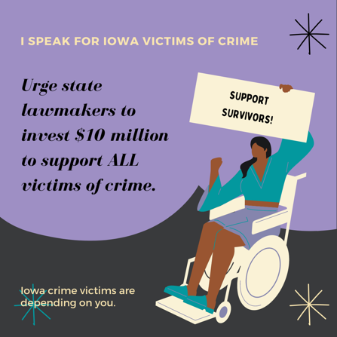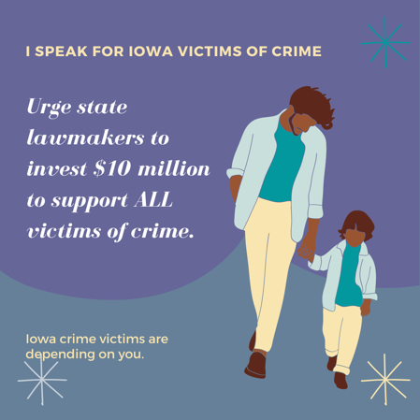

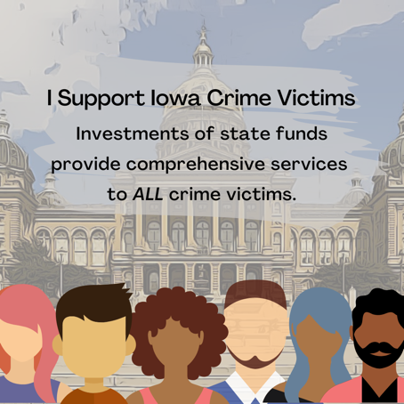

Twitter (right click on an image and click, “Save As” in the pop-up menu and download the picture to your desktop
to post.)

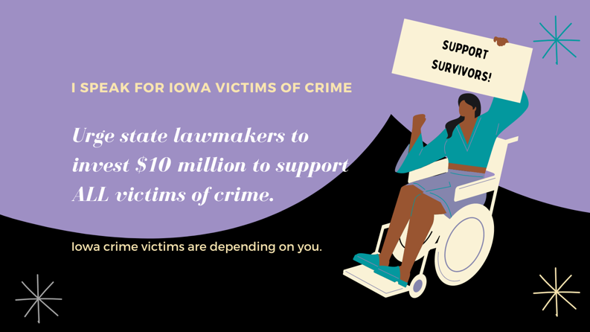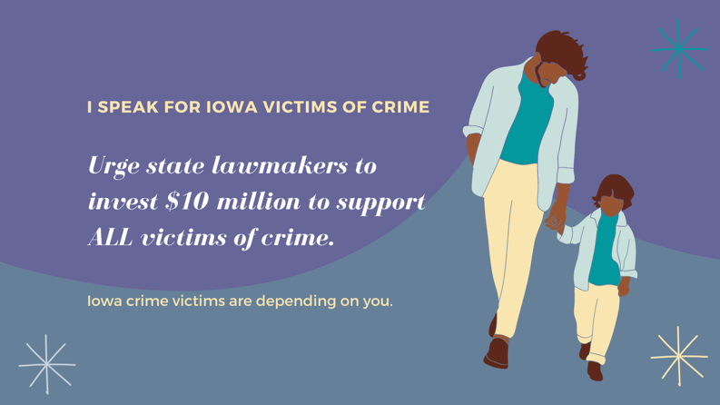

Twitter Graphics Continued
